Confirmatory 1B Analysis Markdown Part 2

# PREPARATION

## Load Packages

## Read in 1B data

## Select only relevant 1B data

## Read in 1A data

## Select only relevant 1A data

## Merge 1A and 1B data into one dataframe

## First factor: Subfield

## Second factor: Time period

# DATA ANOVA

## Coefficient covariances computed by hccm()

## ANOVA Table (type II tests)  
##   
## Effect DFn DFd F  
## 1 subfield_groups 3 507 3.740  
## 2 time_period 1 507 248.977  
## 3 subfield_groups:time_period 3 507 2.282  
## p p<.05 ges  
## 1 0.01099999999999999936162176084053498925641179085 * 0.022  
## 2 0.00000000000000000000000000000000000000000000064 * 0.329  
## 3 0.07799999999999999988897769753748434595763683319 0.013

Our two-way between-subjects ANOVA generated a significant main effect of subfield, F(3, 507) = 3.74, p = 0.011, ges = 0.022, and time period, F(1, 507) = 248.977, p = 0, ges = 0.329. However, the interaction between subfield and time period, F(3, 507) = 2.282, ges = 0.013, was not statistically significant.

## Anova Table (Type 2 tests)  
##   
## Response: total_data_score  
## num Df den Df MSE F ges  
## time_period 1 507 55.28 248.9767 0.32934  
## subfield_groups 3 507 55.28 3.7402 0.02165  
## time_period:subfield_groups 3 507 55.28 2.2820 0.01332  
## Pr(>F)   
## time_period < 0.0000000000000002 ***  
## subfield_groups 0.01115 *   
## time_period:subfield_groups 0.07832 .   
## ---  
## Signif. codes: 0 '***' 0.001 '**' 0.01 '*' 0.05 '.' 0.1 ' ' 1

(#tab:unnamed-chunk-10)

Between-subjects ANOVA for Open Data Scores

|  |  |  |  |  |  |  |
| --- | --- | --- | --- | --- | --- | --- |
| Effect | $$F$$ | $${df}_{1}$$ | $${df}_{2}$$ | $$MSE$$ | $$p$$ | $${\hat{η}}_{G}^{2}$$ |
| Time period | 248.98 | 1 | 507 | 55.28 | < .001 | .329 |
| Subfield groups | 3.74 | 3 | 507 | 55.28 | .011 | .022 |
| Time period $×$ Subfield groups | 2.28 | 3 | 507 | 55.28 | .078 | .013 |

*Note.* This table was created with apa_table().

Our two-way between-subjects ANOVA generated a significant main effect of time period, $F(1,507)=248.98$, $MSE=55.28$, $p<.001$, ${\hat{η}}_{G}^{2}=.329$, and a significant main effect of subfield, $F(3,507)=3.74$, $MSE=55.28$, $p=.011$, ${\hat{η}}_{G}^{2}=.022$. However, the interaction between time period and subfield, $F(3,507)=2.28$, $MSE=55.28$, $p=.078$, ${\hat{η}}_{G}^{2}=.013$, was not statistically significant.

# MATERIALS ANOVA Analysis

## Coefficient covariances computed by hccm()

## ANOVA Table (type II tests)  
##   
## Effect DFn DFd F p p<.05  
## 1 subfield_groups 3 507 8.170 0.0000254999999999999998 *  
## 2 time_period 1 507 90.177 0.0000000000000000000856 *  
## 3 subfield_groups:time_period 3 507 2.072 0.1029999999999999943379   
## ges  
## 1 0.046  
## 2 0.151  
## 3 0.012

Our two-way between-subjects ANOVA generated a significant main effect of subfield, F(3, 507) = 8.17, p = 0.0000255, ges = 0.046, and time period, F(1, 507) = 90.177, p = 0, ges = 0.151. However, the interaction between subfield and time period, F(3, 507) = 2.072, ges = 0.012, was not statistically significant.

## Contrasts set to contr.sum for the following variables: time_period, subfield_groups

## Anova Table (Type 2 tests)  
##   
## Response: total_materials_score  
## num Df den Df MSE F ges  
## time_period 1 507 40.206 90.1769 0.151005  
## subfield_groups 3 507 40.206 8.1700 0.046114  
## time_period:subfield_groups 3 507 40.206 2.0716 0.012110  
## Pr(>F)   
## time_period < 0.00000000000000022 ***  
## subfield_groups 0.00002547 ***  
## time_period:subfield_groups 0.103   
## ---  
## Signif. codes: 0 '***' 0.001 '**' 0.01 '*' 0.05 '.' 0.1 ' ' 1

(#tab:unnamed-chunk-12)

Between-subjects ANOVA for Open Materials Scores

|  |  |  |  |  |  |  |
| --- | --- | --- | --- | --- | --- | --- |
| Effect | $$F$$ | $${df}_{1}$$ | $${df}_{2}$$ | $$MSE$$ | $$p$$ | $${\hat{η}}_{G}^{2}$$ |
| Time period | 90.18 | 1 | 507 | 40.21 | < .001 | .151 |
| Subfield groups | 8.17 | 3 | 507 | 40.21 | < .001 | .046 |
| Time period $×$ Subfield groups | 2.07 | 3 | 507 | 40.21 | .103 | .012 |

*Note.* This table was created with apa_table().

Our two-way between-subjects ANOVA generated a significant main effect of subfield, $F(3,507)=8.17$, $MSE=40.21$, $p<.001$, ${\hat{η}}_{G}^{2}=.046$, and time period, $F(1,507)=90.18$, $MSE=40.21$, $p<.001$, ${\hat{η}}_{G}^{2}=.151$. However, the interaction between time period and subfield, $F(3,507)=2.07$, $MSE=40.21$, $p=.103$, ${\hat{η}}_{G}^{2}=.012$, was not statistically significant.

# PLOTS

## DATA

### Subfield x Data Score

## # A tibble: 4 × 5  
## subfield_groups mean_data_score SD N stderr  
## <fct> <dbl> <dbl> <int> <dbl>  
## 1 Cognition 9.33 9.67 152 0.784  
## 2 Development 5.86 8.55 99 0.860  
## 3 Other 6.45 8.68 116 0.806  
## 4 Social 7.97 9.12 148 0.749

### Time Period x Data Score

## # A tibble: 2 × 5  
## time_period mean_data_score SD N stderr  
## <fct> <dbl> <dbl> <int> <dbl>  
## 1 2014-15 3.57 6.71 322 0.374  
## 2 2019-20 14.4 8.71 193 0.627

### Interaction between time and subfield - Data scores

## `summarise()` has grouped output by 'subfield_groups'. You can override using the `.groups` argument.

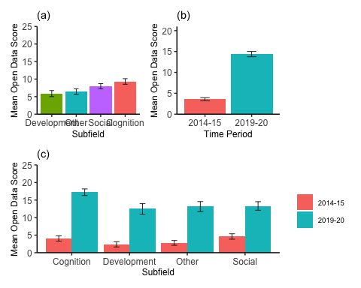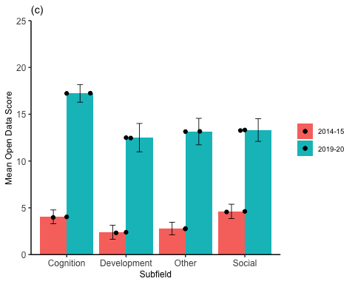

## MATERIALS

### Subfield x Materials Score

### Time Period x Materials Score

### Interaction between time and subfield - Materials Score

## `summarise()` has grouped output by 'subfield_groups'. You can override using the `.groups` argument.

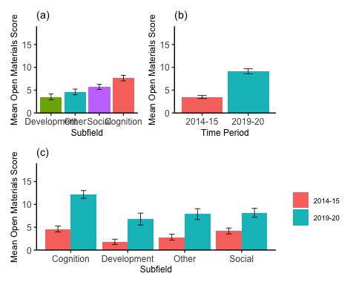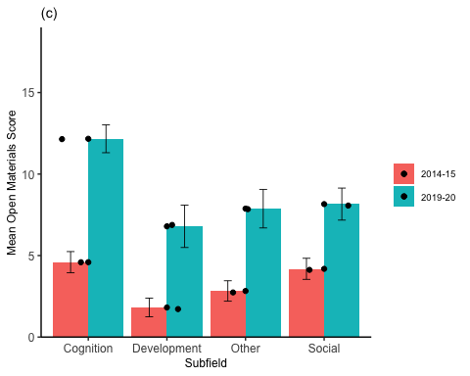

# SUBFIELD T-TESTS

## DATA

### Development vs. Cognition

An independent samples t-test showed that articles published in the field of Cognition generated higher Open Data Scores, on average, than articles published in the field of Developmental Psychology,

## t(226.98) = 2.98, p = .003, d = 0.38

### Development vs. Social

An independent samples t-test showed that articles published in the field of Social Psychology did not generate statistically significant different Open Data Scores, on average, than articles published in the field of Developmental Psychology,

## t(219.13) = -1.85, p = .066, d = -0.24

### Development vs. Other

An independent samples t-test showed that articles published in the Other subfield did not generate statistically significant different Open Data Scores, on average, than articles published in the field of Developmental Psychology,

## t(208.60) = -0.50, p = .617, d = -0.07

## MATERIAL

### Developmental vs. Cognition

An independent samples t-test showed that articles published in the field of Cognition generated higher Open Materials Scores, on average, than articles published in the field of Developmental Psychology,

## t(232.75) = 4.74, p < .001, d = 0.59

### Developmental vs. Social

An independent samples t-test showed that articles published in the field of Social Psychology generated higher Open Materials Scores, on average, than articles published in the field of Developmental Psychology,

## t(224.53) = -2.59, p = .010, d = -0.33

### Developmental vs. Other

An independent samples t-test showed that articles published in the Other subfield did not generate statistically significant different Open Materials Scores, on average, than articles published in the field of Developmental Psychology,

## t(211.35) = -1.23, p = .220, d = -0.17